Mixed Possion distribution

Intro

Parameter



Support



PDF



Expected Value

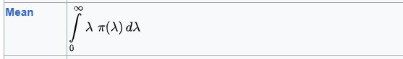

Variance



Skewness

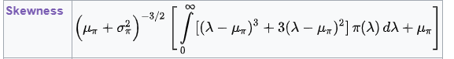

MGF



CF



PGF



Property

Overdispersion

$$Var\left(X\right)>E\left[X\right]$$

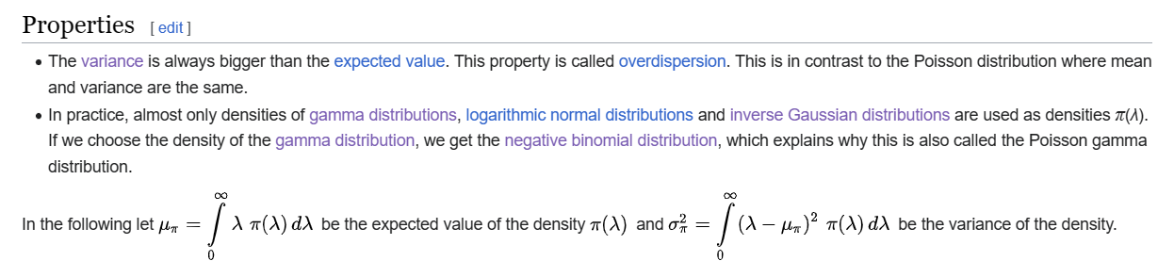

Theorem

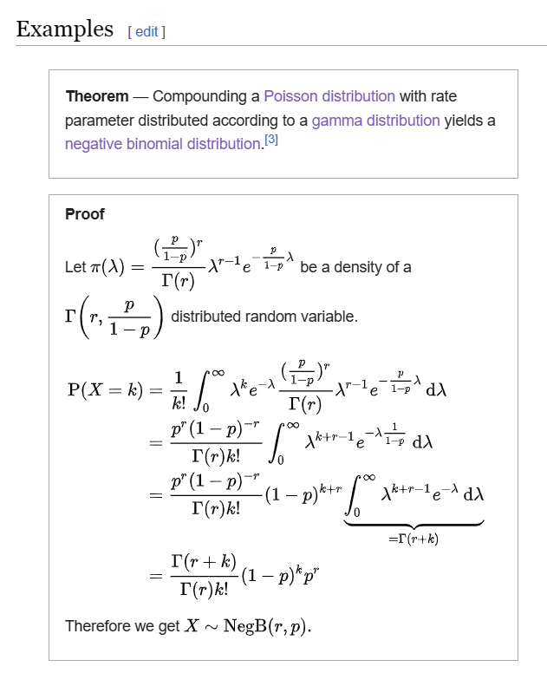

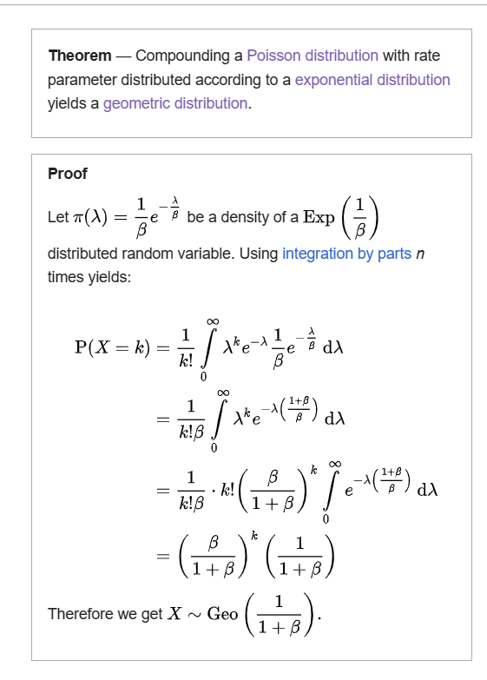

Table

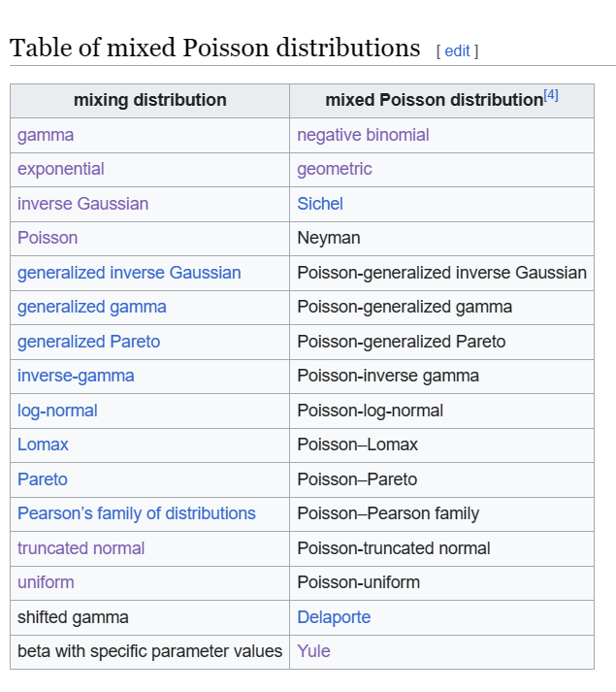

Ref

[Mixed Poisson distribution - Wikipedia](https://en.wikipedia.org/wiki/Mixed_Poisson_distribution)